**React JS Home**

React is a front-end library developed by Facebook. It is used for handling the view layer for web and mobile apps. ReactJS allows us to create reusable UI components. It is currently one of the most popular JavaScript libraries and has a strong foundation and large community behind it.

**Audience**

This tutorial will help JavaScript developers who look ahead to deal with ReactJS for the first time. We will try to introduce every concept by showing simple code examples that can be easily understood. After finishing all the chapters, you will feel confident working with ReactJS. As a bonus we will introduce additional elements that work well with ReactJS to help you learn the best practices and follow the modern JavaScript trends.

**Prerequisites**

If you want to work with ReactJS, you need to have solid knowledge of **JavaScript, HTML5**, and **CSS**. Even though ReactJS doesn't use HTML, the JSX is similar so your HTML knowledge will be very helpful. We will explain this more in one of the next chapters. We will also use **EcmaScript 2015** syntax so any knowledge in this area can be helpful.

**React JS Overview**

ReactJS is JavaScript library used for building reusable UI components. According to React official documentation, following is the definition −

React is a library for building composable user interfaces. It encourages the creation of reusable UI components, which present data that changes over time. Lots of people use React as the V in MVC. React abstracts away the DOM from you, offering a simpler programming model and better performance. React can also render on the server using Node, and it can power native apps using React Native. React implements one-way reactive data flow, which reduces the boilerplate and is easier to reason about than traditional data binding.

## React Features

* **JSX** − JSX is JavaScript syntax extension. It isn't necessary to use JSX in React development, but it is recommended.
* **Components** − React is all about components. You need to think of everything as a component. This will help you maintain the code when working on larger scale projects.
* **Unidirectional data flow and Flux** − React implements one-way data flow which makes it easy to reason about your app. Flux is a pattern that helps keeping your data unidirectional.
* **License** − React is licensed under the Facebook Inc. Documentation is licensed under CC BY 4.0.

## React Advantages

* Uses virtual DOM which is a JavaScript object. This will improve apps performance, since JavaScript virtual DOM is faster than the regular DOM.
* Can be used on client and server side as well as with other frameworks.
* Component and data patterns improve readability, which helps to maintain larger apps.

## React Limitations

* Covers only the view layer of the app, hence you still need to choose other technologies to get a complete tooling set for development.
* Uses inline templating and JSX, which might seem awkward to some developers.

**React JS Installation**

**FIRST METHOD-**

* First install the node js application
* Got o command promt(node prompt or windows prompt)
* Run this command
* “npm install –g create-react-app “
* “create-react-app my-app”
* Now you have setup your first react application name as “my-app”
* Type cd my-app
* “npm start”
* Your application will run on the server and will open on the web browser.

**SECOND METHOD –**

In this chapter, we will show you how to set up an environment for successful React development. Notice that there are many steps involved but this will help speed up the development process later. We will need **NodeJS**, so if you don't have it installed, check the link from the following table.

|  |  |
| --- | --- |
| **Sr. No.** | **Software & Description** |
| 1 | **NodeJS and NPM**  NodeJS is the platform needed for the ReactJS development. Checkout our [NodeJS Environment Setup](https://www.tutorialspoint.com/nodejs/nodejs_environment_setup.htm). |

## Step 1 - Create the Root Folder

The root folder will be named **reactApp** and we will place it on **Desktop**. After the folder is created, we need to open it and create empty **package.json** file inside by running npm init from the **command prompt** and follow the instructions.

C:\Users\username\Desktop>mkdir reactApp

C:\Users\username\Desktop\reactApp>npm init

## Step 2 - Install Global Packages

We will need to install several packages for this setup. We will need some of the **babel** plugins, so let's first install **babel** by running the following code in the **command prompt** window.

C:\Users\username\Desktop\reactApp>npm install -g babel

C:\Users\username\Desktop\reactApp>npm install -g babel-cli

## Step 3 - Add Dependencies and Plugins

We will use **webpack** bundler in these tutorial. Let's install **webpack** and **webpack-dev-server**.

C:\Users\username\Desktop\reactApp>npm install webpack --save

C:\Users\username\Desktop\reactApp>npm install webpack-dev-server --save

Since we want to use React, we need to install it first. The **--save** command will add these packages to **package.json** file.

C:\Users\username\Desktop\reactApp>npm install react --save

C:\Users\username\Desktop\reactApp>npm install react-dom --save

As already mentioned, we will need some **babel** plugins, so let's install it too.

C:\Users\username\Desktop\reactApp>npm install babel-core

C:\Users\username\Desktop\reactApp>npm install babel-loader

C:\Users\username\Desktop\reactApp>npm install babel-preset-react

C:\Users\username\Desktop\reactApp>npm install babel-preset-es2015

## Step 4 - Create the Files

Let's create several files that we need. It can be added manually or using the **command prompt**.

C:\Users\username\Desktop\reactApp>touch index.html

C:\Users\username\Desktop\reactApp>touch App.jsx

C:\Users\username\Desktop\reactApp>touch main.js

C:\Users\username\Desktop\reactApp>touch webpack.config.js

Alternative way to create files that we need

C:\Users\username\Desktop\reactApp>type nul >index.html

C:\Users\username\Desktop\reactApp>type nul >App.jsx

C:\Users\username\Desktop\reactApp>type nul >main.js

C:\Users\username\Desktop\reactApp>type nul >webpack.config.js

## Step 5 - Set Compiler, Server and Loaders

Open **webpack.config.js** file and add the following code. We are setting webpack entry point to be **main.js**. Output path is the place where bundled app will be served. We are also setting the development server to **8080** port. You can choose any port you want.

And lastly, we are setting babel loaders to search for **js** files, and use **es2015** and **react** presets that we installed before.

### webpack.config.js

var config = {

entry: './main.js',

output: {

path:'/',

filename: 'index.js',

},

devServer: {

inline: true,

port: 8080

},

module: {

loaders: [

{

test: /\.jsx?$/,

exclude: /node_modules/,

loader: 'babel-loader',

query: {

presets: ['es2015', 'react']

}

}

]

}

}

module.exports = config;

Open the **package.json** and delete **"test" "echo \"Error: no test specified\" && exit 1"** inside **"scripts"** object. We are deleting this line since we will not do any testing in this tutorial. Let's add the **start** command instead.

"start": "webpack-dev-server --hot"

Before the above step, it will required **webpack-dev-server**. To install **webpack-dev-server**, use the following command.

C:\Users\username\Desktop\reactApp>npm install webpack-dev-server -g

Now, we can use **npm start** command to start the server. **--hot** command will add live reload after something is changed inside our files so we don't need to refresh the browser every time we change our code.

## Step 6 - index.html

This is just regular HTML. We are setting **div id = "app"** as a root element for our app and adding **index.js** script, which is our bundled app file.

<!DOCTYPE html>

<html lang = "en">

<head>

<meta charset = "UTF-8">

<title>React App</title>

</head>

<body>

<div id = "app"></div>

<script src = "index.js"></script>

</body>

</html>

## Step 7 - App.jsx and main.js

This is the first React component. We will explain React components in depth in a subsequent chapter. This component will render **Hello World!!!**.

### App.jsx

import React from 'react';

class App extends React.Component {

render() {

return (

<div>

Hello World!!!

</div>

);

}

}

export default App;

We need to import this component and render it to our root **App** element, so we can see it in the browser.

### main.js

import React from 'react';

import ReactDOM from 'react-dom';

import App from './App.jsx';

ReactDOM.render(<App />, document.getElementById('app'));

**Note** − Whenever you want to use something, you need to **import** it first. If you want to make the component usable in other parts of the app, you need to **export** it after creation and **import** it in the file where you want to use it.

## Step 8 - Running the Server

The setup is complete and we can start the server by running the following command.

C:\Users\username\Desktop\reactApp>npm start

It will show the port we need to open in the browser. In our case, it is **http://localhost:8080/**. After we open it, we will see the following output.

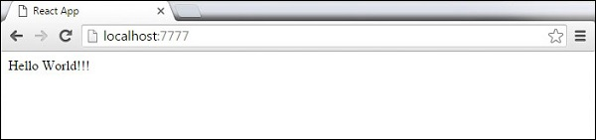

**React JS JSX**

React uses JSX for templating instead of regular JavaScript. It is not necessary to use it, however, following are some pros that come with it.

* It is faster because it performs optimization while compiling code to JavaScript.
* It is also type-safe and most of the errors can be caught during compilation.
* It makes it easier and faster to write templates, if you are familiar with HTML.

## Using JSX

JSX looks like a regular HTML in most cases. We already used it in the Environment Setup chapter. Look at the code from **App.jsx** where we are returning **div**.

### App.jsx

import React from 'react';

class App extends React.Component {

render() {

return (

<div>

Hello World!!!

</div>

);

}

}

export default App;

Even though it's similar to HTML, there are a couple of things we need to keep in mind when working with JSX.

## Nested Elements

If we want to return more elements, we need to wrap it with one container element. Notice how we are using **div** as a wrapper for **h1**, **h2** and **p** elements.

### App.jsx

import React from 'react';

class App extends React.Component {

render() {

return (

<div>

<h1>Header</h1>

<h2>Content</h2>

<p>This is the content!!!</p>

</div>

);

}

}

export default App;

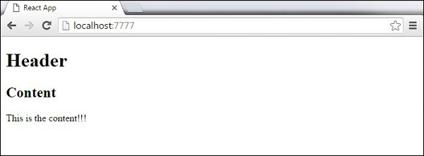

## Attributes

We can use our own custom attributes in addition to regular HTML properties and attributes. When we want to add custom attribute, we need to use **data-** prefix. In the following example, we added **data-myattribute** as an attribute of **p** element.

import React from 'react';

class App extends React.Component {

render() {

return (

<div>

<h1>Header</h1>

<h2>Content</h2>

<p data-myattribute = "somevalue">This is the content!!!</p>

</div>

);

}

}

export default App;

## JavaScript Expressions

JavaScript expressions can be used inside of JSX. We just need to wrap it with curly brackets **{}**. The following example will render **2**.

import React from 'react';

class App extends React.Component {

render() {

return (

<div>

<h1>{1+1}</h1>

</div>

);

}

}

export default App;

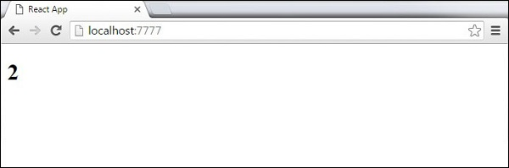

We cannot use **if else** statements inside JSX, instead we can use **conditional (ternary)** expressions. In the following example, variable **i** equals to **1** so the browser will render **true**, If we change it to some other value, it will render **false**.

import React from 'react';

class App extends React.Component {

render() {

var i = 1;

return (

<div>

<h1>{i == 1 ? 'True!' : 'False'}</h1>

</div>

);

}

}

export default App;

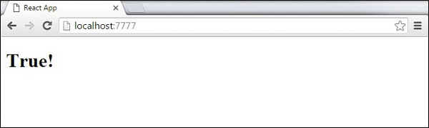

## Styling

React recommends using inline styles. When we want to set inline styles, we need to use **camelCase** syntax. React will also automatically append **px** after the number value on specific elements. The following example shows how to add **myStyle** inline to **h1** element.

import React from 'react';

class App extends React.Component {

render() {

var myStyle = {

fontSize: 100,

color: '#FF0000'

}

return (

<div>

<h1 style = {myStyle}>Header</h1>

</div>

);

}

}

export default App;

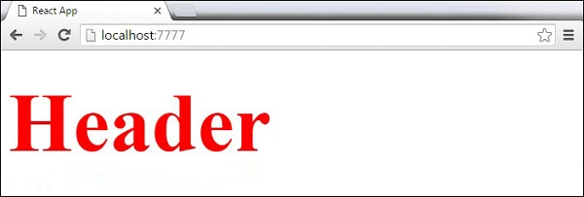

## Comments

When writing comments, we need to put curly brackets **{}** when we want to write comment within children section of a tag. It is a good practice to always use **{}** when writing comments, since we want to be consistent when writing the app.

import React from 'react';

class App extends React.Component {

render() {

return (

<div>

<h1>Header</h1>

{//End of the line Comment...}

{/*Multi line comment...*/}

</div>

);

}

}

export default App;

## Naming Convention

HTML tags always use **lowercase** tag names, while React components start with **Uppercase**.

**Note** − You should use **className** and **htmlFor** as XML attribute names instead of **class** and **for**.

This is explained on React official page as −

Since JSX is JavaScript, identifiers such as **class** and **for** are discouraged as XML attribute names. Instead, React DOM components expect DOM property names such as **className** and **htmlFor**, respectively.

**React JS Components -**

In this chapter, we will learn how to combine components to make the app easier to maintain. This approach allows to update and change your components without affecting the rest of the page.

## Stateless Example

Our first component in the following example is **App**. This component is owner of **Header** and **Content**. We are creating **Header** and **Content** separately and just adding it inside JSX tree in our **App** component. Only **App** component needs to be exported.

### App.jsx

import React from 'react';

class App extends React.Component {

render() {

return (

<div>

<Header/>

<Content/>

</div>

);

}

}

class Header extends React.Component {

render() {

return (

<div>

<h1>Header</h1>

</div>

);

}

}

class Content extends React.Component {

render() {

return (

<div>

<h2>Content</h2>

<p>The content text!!!</p>

</div>

);

}

}

export default App;

To be able to render this on the page, we need to import it in **main.js** file and call **reactDOM.render()**. We already did this while setting the environment.

### main.js

import React from 'react';

import ReactDOM from 'react-dom';

import App from './App.jsx';

ReactDOM.render(<App />, document.getElementById('app'));

The above code will generate the following result.

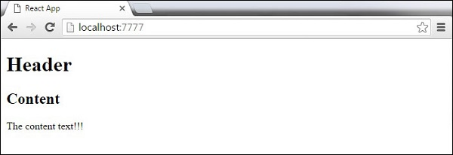

## Stateful Example

In this example, we will set the state for owner component (**App**). The **Header** component is just added like in the last example since it doesn't need any state. Instead of content tag, we are creating **table** and **tbody** elements, where we will dynamically insert **TableRow** for every object from the **data** array.

It can be seen that we are using EcmaScript 2015 arrow syntax (**⇒**) which looks much cleaner than the old JavaScript syntax. This will help us create our elements with fewer lines of code. It is especially useful when we need to create a list with a lot of items.

### App.jsx

import React from 'react';

class App extends React.Component {

constructor() {

super();

this.state = {

data:

[

{

"id":1,

"name":"Foo",

"age":"20"

},

{

"id":2,

"name":"Bar",

"age":"30"

},

{

"id":3,

"name":"Baz",

"age":"40"

}

]

}

}

render() {

return (

<div>

<Header/>

<table>

<tbody>

{this.state.data.map((person, i) => <TableRow key = {i}

data = {person} />)}

</tbody>

</table>

</div>

);

}

}

class Header extends React.Component {

render() {

return (

<div>

<h1>Header</h1>

</div>

);

}

}

class TableRow extends React.Component {

render() {

return (

<tr>

<td>{this.props.data.id}</td>

<td>{this.props.data.name}</td>

<td>{this.props.data.age}</td>

</tr>

);

}

}

export default App;

### main.js

import React from 'react';

import ReactDOM from 'react-dom';

import App from './App.jsx';

ReactDOM.render(<App/>, document.getElementById('app'));

**Note** − Notice that we are using **key = {i} inside map()** function. This will help React to update only the necessary elements instead of re-rendering the entire list when something changes. It is a huge performance boost for larger number of dynamically created elements.

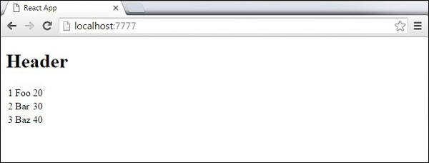

**React JS State**

**State** is the place where the data comes from. We should always try to make our state as simple as possible and minimize the number of stateful components. If we have, for example, ten components that need data from the state, we should create one container component that will keep the state for all of them.

## Using Props

The following sample code shows how to create a stateful component using EcmaScript2016 syntax.

### App.jsx

import React from 'react';

class App extends React.Component {

constructor(props) {

super(props);

this.state = {

header: "Header from state...",

content: "Content from state..."

}

}

render() {

return (

<div>

<h1>{this.state.header}</h1>

<h2>{this.state.content}</h2>

</div>

);

}

}

export default App;

### main.js

import React from 'react';

import ReactDOM from 'react-dom';

import App from './App.jsx';

ReactDOM.render(<App />, document.getElementById('app'));

This will produce the following result.

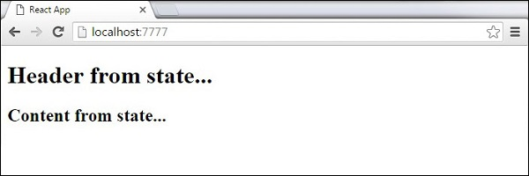

**React JS Overview**

The main difference between state and props is that **props** are immutable. This is why the container component should define the state that can be updated and changed, while the child components should only pass data from the state using props.

## Using Props

When we need immutable data in our component, we can just add props to **reactDOM.render()** function in **main.js** and use it inside our component.

### App.jsx

import React from 'react';

class App extends React.Component {

render() {

return (

<div>

<h1>{this.props.headerProp}</h1>

<h2>{this.props.contentProp}</h2>

</div>

);

}

}

export default App;

### main.js

import React from 'react';

import ReactDOM from 'react-dom';

import App from './App.jsx';

ReactDOM.render(<App headerProp = "Header from props..." contentProp = "Content

from props..."/>, document.getElementById('app'));

export default App;

This will produce the following result.

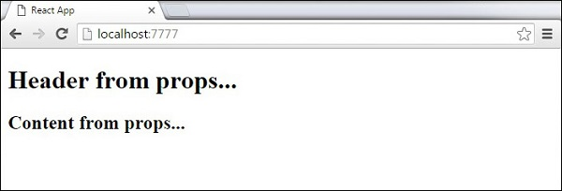

## Default Props

You can also set default property values directly on the component constructor instead of adding it to the **reactDom.render()** element.

### App.jsx

import React from 'react';

class App extends React.Component {

render() {

return (

<div>

<h1>{this.props.headerProp}</h1>

<h2>{this.props.contentProp}</h2>

</div>

);

}

}

App.defaultProps = {

headerProp: "Header from props...",

contentProp:"Content from props..."

}

export default App;

### main.js

import React from 'react';

import ReactDOM from 'react-dom';

import App from './App.jsx';

ReactDOM.render(<App/>, document.getElementById('app'));

Output is the same as before.



## State and Props

The following example shows how to combine **state** and props in your app. We are setting the state in our parent component and passing it down the component tree using **props**. Inside the **render** function, we are setting **headerProp** and **contentProp** used in child components.

### App.jsx

import React from 'react';

class App extends React.Component {

constructor(props) {

super(props);

this.state = {

header: "Header from props...",

content: "Content from props..."

}

}

render() {

return (

<div>

<Header headerProp = {this.state.header}/>

<Content contentProp = {this.state.content}/>

</div>

);

}

}

class Header extends React.Component {

render() {

return (

<div>

<h1>{this.props.headerProp}</h1>

</div>

);

}

}

class Content extends React.Component {

render() {

return (

<div>

<h2>{this.props.contentProp}</h2>

</div>

);

}

}

export default App;

### main.js

import React from 'react';

import ReactDOM from 'react-dom';

import App from './App.jsx';

ReactDOM.render(<App/>, document.getElementById('app'));

The result will again be the same as in the previous two examples, the only thing that is different is the source of our data, which is now originally coming from the **state**. When we want to update it, we just need to update the state, and all child components will be updated. More on this in the Events chapter.



**React JS Props Validation**

Properties validation is a useful way to force the correct usage of the components. This will help during development to avoid future bugs and problems, once the app becomes larger. It also makes the code more readable, since we can see how each component should be used.

## Validating Props

In this example, we are creating **App** component with all the **props** that we need. **App.propTypes** is used for props validation. If some of the props aren't using the correct type that we assigned, we will get a console warning. After we specify validation patterns, we will set **App.defaultProps**.

### App.jsx

import PropTypes from 'prop-types';

import React from 'react';

import ReactDOM from 'react-dom';

class App extends React.Component {

render() {

return (

<div>

<h1> Hello, {this.props.name} </h1>

<h3>Array: {this.props.propArray}</h3>

<h3>Bool: {this.props.propBool ? "True..." : "False..."}</h3>

<h3>Func: {this.props.propFunc(3)}</h3>

<h3>Number: {this.props.propNumber}</h3>

<h3>String: {this.props.propString}</h3>

</div>

);

}

}

App.propTypes = {

name: PropTypes.string,

propArray: PropTypes.array.isRequired,

propBool: PropTypes.bool.isRequired,

propFunc: PropTypes.func,

propNumber: PropTypes.number,

propString: PropTypes.string,

};

App.defaultProps = {

name: 'Tutorialspoint.com',

propArray: [1, 2, 3, 4, 5],

propBool: true,

propFunc: function(e) {

return e

},

propNumber: 1,

propString: "String value..."

}

export default App;

### main.js

import React from 'react';

import PropTypes from 'prop-types';

import ReactDOM from 'react-dom';

import App from './App.jsx';

ReactDOM.render(<App/>, document.getElementById('app'));

### webpack.config.js

var config = {

entry: './main.js',

output: {

path:'/',

filename: 'index.js',

},

devServer: {

inline: true,

port: 8080

},

externals: {

'react': 'React'

},

module: {

loaders: [

{

test: /\.jsx?$/,

exclude: /node_modules/,

loader: 'babel-loader',

query: {

presets: ['es2015', 'react']

}

}

]

}

}

module.exports = config;

Since all **props** are valid, we will get the following result.

As can be noticed, we have use **isRequired** when validating **propArray** and **propBool**. This will give us an error, if one of those two don't exist. If we delete **propArray:** **[1,2,3,4,5]** from the **App.defaultProps** object, the console will log a warning.

React Props Validation Error

If we set the value of **propArray: 1**, React will warn us that the propType validation has failed, since we need an array and we got a number.

React Props Validation Error 2

**React JS Component API**

In this chapter, we will explain React component API. We will discuss three methods: **setState(), forceUpdate** and **ReactDOM.findDOMNode()**. In new ES6 classes, we have to manually bind this. We will use **this.method.bind(this)** in the examples.

## Set State

**setState()** method is used to update the state of the component. This method will not replace the state, but only add changes to the original state.

import React from 'react';

class App extends React.Component {

constructor() {

super();

this.state = {

data: []

}

this.setStateHandler = this.setStateHandler.bind(this);

};

setStateHandler() {

var item = "setState..."

var myArray = this.state.data.slice();

myArray.push(item);

this.setState({data: myArray})

};

render() {

return (

<div>

<button onClick = {this.setStateHandler}>SET STATE</button>

<h4>State Array: {this.state.data}</h4>

</div>

);

}

}

export default App;

We started with an empty array. Every time we click the button, the state will be updated. If we click five times, we will get the following output.

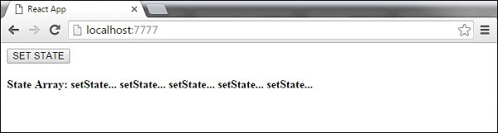

## Force Update

Sometimes we might want to update the component manually. This can be achieved using the **forceUpdate()** method.

import React from 'react';

class App extends React.Component {

constructor() {

super();

this.forceUpdateHandler = this.forceUpdateHandler.bind(this);

};

forceUpdateHandler() {

this.forceUpdate();

};

render() {

return (

<div>

<button onClick = {this.forceUpdateHandler}>FORCE UPDATE</button>

<h4>Random number: {Math.random()}</h4>

</div>

);

}

}

export default App;

We are setting a random number that will be updated every time the button is clicked.

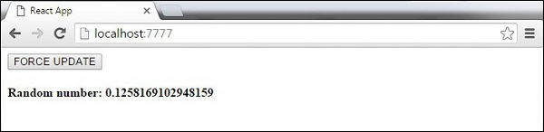

## Find Dom Node

For DOM manipulation, we can use **ReactDOM.findDOMNode()** method. First we need to import **react-dom**.

import React from 'react';

import ReactDOM from 'react-dom';

class App extends React.Component {

constructor() {

super();

this.findDomNodeHandler = this.findDomNodeHandler.bind(this);

};

findDomNodeHandler() {

var myDiv = document.getElementById('myDiv');

ReactDOM.findDOMNode(myDiv).style.color = 'green';

}

render() {

return (

<div>

<button onClick = {this.findDomNodeHandler}>FIND DOME NODE</button>

<div id = "myDiv">NODE</div>

</div>

);

}

}

export default App;

The color of **myDiv** element changes to green, once the button is clicked.

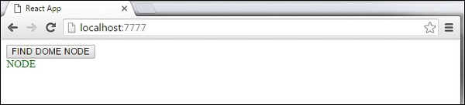

**Note** − Since the 0.14 update, most of the older component API methods are deprecated or removed to accommodate ES6.

React JS Component Life cycle-

In this chapter, we will discuss component lifecycle methods.

## Lifecycle Methods

* **componentWillMount** is executed before rendering, on both the server and the client side.
* **componentDidMount** is executed after the first render only on the client side. This is where AJAX requests and DOM or state updates should occur. This method is also used for integration with other JavaScript frameworks and any functions with delayed execution such as **setTimeout** or **setInterval**. We are using it to update the state so we can trigger the other lifecycle methods.
* **componentWillReceiveProps** is invoked as soon as the props are updated before another render is called. We triggered it from **setNewNumber** when we updated the state.
* **shouldComponentUpdate** should return **true** or **false** value. This will determine if the component will be updated or not. This is set to **true** by default. If you are sure that the component doesn't need to render after **state** or **props** are updated, you can return **false** value.
* **componentWillUpdate** is called just before rendering.
* **componentDidUpdate** is called just after rendering.
* **componentWillUnmount** is called after the component is unmounted from the dom. We are unmounting our component in **main.js**.

In the following example, we will set the initial **state** in the constructor function. The **setNewnumber** is used to update the **state**. All the lifecycle methods are inside the Content component.

### App.jsx

import React from 'react';

class App extends React.Component {

constructor(props) {

super(props);

this.state = {

data: 0

}

this.setNewNumber = this.setNewNumber.bind(this)

};

setNewNumber() {

this.setState({data: this.state.data + 1})

}

render() {

return (

<div>

<button onClick = {this.setNewNumber}>INCREMENT</button>

<Content myNumber = {this.state.data}></Content>

</div>

);

}

}

class Content extends React.Component {

componentWillMount() {

console.log('Component WILL MOUNT!')

}

componentDidMount() {

console.log('Component DID MOUNT!')

}

componentWillReceiveProps(newProps) {

console.log('Component WILL RECIEVE PROPS!')

}

shouldComponentUpdate(newProps, newState) {

return true;

}

componentWillUpdate(nextProps, nextState) {

console.log('Component WILL UPDATE!');

}

componentDidUpdate(prevProps, prevState) {

console.log('Component DID UPDATE!')

}

componentWillUnmount() {

console.log('Component WILL UNMOUNT!')

}

render() {

return (

<div>

<h3>{this.props.myNumber}</h3>

</div>

);

}

}

export default App;

### main.js

import React from 'react';

import ReactDOM from 'react-dom';

import App from './App.jsx';

ReactDOM.render(<App/>, document.getElementById('app'));

setTimeout(() => {

ReactDOM.unmountComponentAtNode(document.getElementById('app'));}, 10000);

After the initial render, we will get the following screen.

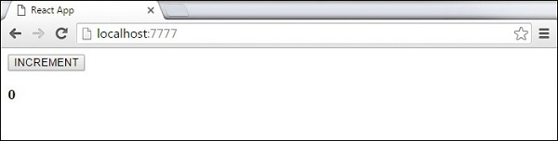

Only **componentWillMount** and **componentDidMount** will be logged in the console, since we didn't update anything yet.

React Component Lifecycle Initial Log

When we click the **INCREMENT** button, the update will occur and other lifecycle methods will be triggered.

React Component Lifecycle Change Log

After ten seconds, the component will unmount and the last event will be logged in the console.

React Component Lifecycle Unmount Log

**Note** − Lifecycle methods will always be invoked in the same order so it is a good practice to write it in the correct order as shown in the example.

React JS - Forms

In this chapter, we will learn how to use forms in React.

## Simple Example

In the following example, we will set an input form with **value = {this.state.data}**. This allows to update the state whenever the input value changes. We are using **onChange** event that will watch the input changes and update the state accordingly.

### App.jsx

import React from 'react';

class App extends React.Component {

constructor(props) {

super(props);

this.state = {

data: 'Initial data...'

}

this.updateState = this.updateState.bind(this);

};

updateState(e) {

this.setState({data: e.target.value});

}

render() {

return (

<div>

<input type = "text" value = {this.state.data}

onChange = {this.updateState} />

<h4>{this.state.data}</h4>

</div>

);

}

}

export default App;

### main.js

import React from 'react';

import ReactDOM from 'react-dom';

import App from './App.jsx';

ReactDOM.render(<App/>, document.getElementById('app'));

When the input text value changes, the state will be updated.

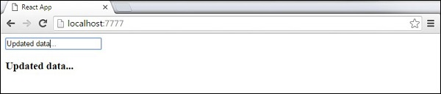

## Complex Example

In the following example, we will see how to use forms from child component. **onChange** method will trigger state update that will be passed to the child input **value** and rendered on the screen. A similar example is used in the Events chapter. Whenever we need to update state from child component, we need to pass the function that will handle updating (**updateState**) as a prop (**updateStateProp**).

### App.jsx

import React from 'react';

class App extends React.Component {

constructor(props) {

super(props);

this.state = {

data: 'Initial data...'

}

this.updateState = this.updateState.bind(this);

};

updateState(e) {

this.setState({data: e.target.value});

}

render() {

return (

<div>

<Content myDataProp = {this.state.data}

updateStateProp = {this.updateState}></Content>

</div>

);

}

}

class Content extends React.Component {

render() {

return (

<div>

<input type = "text" value = {this.props.myDataProp}

onChange = {this.props.updateStateProp} />

<h3>{this.props.myDataProp}</h3>

</div>

);

}

}

export default App;

### main.js

import React from 'react';

import ReactDOM from 'react-dom';

import App from './App.jsx';

ReactDOM.render(<App/>, document.getElementById('app'));

This will produce the following result.

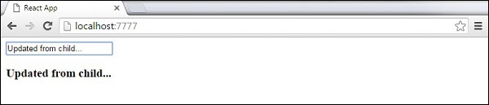

**React JS Events**

In this chapter, we will learn how to use events.

## Simple Example

This is a simple example where we will only use one component. We are just adding **onClick** event that will trigger **updateState** function once the button is clicked.

### App.jsx

import React from 'react';

class App extends React.Component {

constructor(props) {

super(props);

this.state = {

data: 'Initial data...'

}

this.updateState = this.updateState.bind(this);

};

updateState() {

this.setState({data: 'Data updated...'})

}

render() {

return (

<div>

<button onClick = {this.updateState}>CLICK</button>

<h4>{this.state.data}</h4>

</div>

);

}

}

export default App;

### main.js

import React from 'react';

import ReactDOM from 'react-dom';

import App from './App.jsx';

ReactDOM.render(<App/>, document.getElementById('app'));

This will produce the following result.

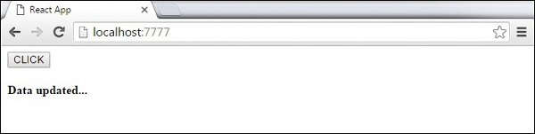

## Child Events

When we need to update the **state** of the parent component from its child, we can create an event handler (**updateState**) in the parent component and pass it as a prop (**updateStateProp**) to the child component where we can just call it.

### App.jsx

import React from 'react';

class App extends React.Component {

constructor(props) {

super(props);

this.state = {

data: 'Initial data...'

}

this.updateState = this.updateState.bind(this);

};

updateState() {

this.setState({data: 'Data updated from the child component...'})

}

render() {

return (

<div>

<Content myDataProp = {this.state.data}

updateStateProp = {this.updateState}></Content>

</div>

);

}

}

class Content extends React.Component {

render() {

return (

<div>

<button onClick = {this.props.updateStateProp}>CLICK</button>

<h3>{this.props.myDataProp}</h3>

</div>

);

}

}

export default App;

### main.js

import React from 'react';

import ReactDOM from 'react-dom';

import App from './App.jsx';

ReactDOM.render(<App/>, document.getElementById('app'));

This will produce the following result.

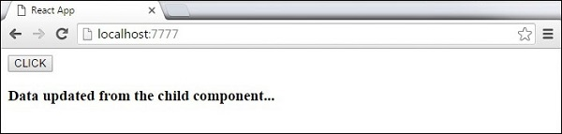

**React JS Ref**

The **ref** is used to return a reference to the element. **Refs** should be avoided in most cases, however, they can be useful when we need DOM measurements or to add methods to the components.

## Using Refs

The following example shows how to use refs to clear the input field. **ClearInput** function searches for element with **ref = "myInput"** value, resets the state, and adds focus to it after the button is clicked.

### App.jsx

import React from 'react';

import ReactDOM from 'react-dom';

class App extends React.Component {

constructor(props) {

super(props);

this.state = {

data: ''

}

this.updateState = this.updateState.bind(this);

this.clearInput = this.clearInput.bind(this);

};

updateState(e) {

this.setState({data: e.target.value});

}

clearInput() {

this.setState({data: ''});

ReactDOM.findDOMNode(this.refs.myInput).focus();

}

render() {

return (

<div>

<input value = {this.state.data} onChange = {this.updateState}

ref = "myInput"></input>

<button onClick = {this.clearInput}>CLEAR</button>

<h4>{this.state.data}</h4>

</div>

);

}

}

export default App;

### main.js

import React from 'react';

import ReactDOM from 'react-dom';

import App from './App.jsx';

ReactDOM.render(<App/>, document.getElementById('app'));

Once the button is clicked, the **input** will be cleared and focused.

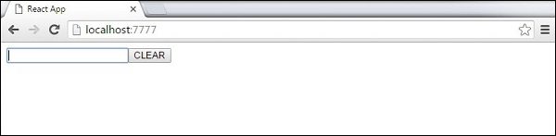

**React JS Keys**

React **keys** are useful when working with dynamically created components or when your lists are altered by the users. Setting the **key** value will keep your components uniquely identified after the change.

## Using Keys

Let's dynamically create **Content** elements with unique index (i). The **map** function will create three elements from our **data** array. Since the **key** value needs to be unique for every element, we will assign i as a key for each created element.

### App.jsx

import React from 'react';

class App extends React.Component {

constructor() {

super();

this.state = {

data:[

{

component: 'First...',

id: 1

},

{

component: 'Second...',

id: 2

},

{

component: 'Third...',

id: 3

}

]

}

}

render() {

return (

<div>

<div>

{this.state.data.map((dynamicComponent, i) => <Content

key = {i} componentData = {dynamicComponent}/>)}

</div>

</div>

);

}

}

class Content extends React.Component {

render() {

return (

<div>

<div>{this.props.componentData.component}</div>

<div>{this.props.componentData.id}</div>

</div>

);

}

}

export default App;

### main.js

import React from 'react';

import ReactDOM from 'react-dom';

import App from './App.jsx';

ReactDOM.render(<App/>, document.getElementById('app'));

We will get the following result for the Key values of each element.

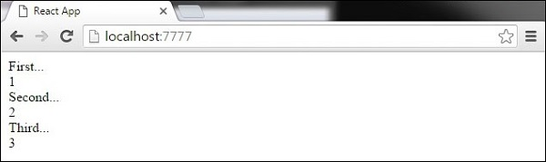

If we add or remove some elements in the future or change the order of the dynamically created elements, React will use the **key** values to keep track of each element.

**React JS -Router**

In this chapter, we will learn how to set up routing for an app.

## Step 1 - Install a React Router

A simple way to install the **react-router** is to run the following code snippet in the **command prompt** window.

C:\Users\username\Desktop\reactApp>npm install react-router-dom

Configure the .babelrc file in the root of the project as shown below-

C:\Users\username\Desktop\reactApp>\type nul>.babelrc

Add the following code in **.babelrc** file

{

"presets": ["es2015", "react"]

}

Create a file as index.html in a root directory and the following code -

<!DOCTYPE html>

<html lang = "en">

<head>

<meta charset = "UTF-8">

<title>React Router Tutorial</title>

</head>

<body>

<div id = "app"></div>

<script type = "text/javascript" src = "bundle.js"></script>

</body>

</html>

To configure webpack.config.js file, add the following code in webpack.config.js

module.exports = {

entry: './app/main.js',

output: {

filename: 'bundle.js'

},

module: {

loaders: [

{

loader: 'babel-loader',

test: /\.js$/,

exclude: /node_modules/

}

]

},

devServer: {

port: 7777

}

};

## Step 2 - Add a Router

Now, we will add routes to the app. Instead of rendering **App** element like in the previous example, create a directory named as **App** and create files and named as main.js and App.js

### Main.js

import React from 'react';

import { render } from 'react-dom';

import App from './App';

render(<App />, document.getElementById('app'));

### App.js

import React, { Component } from 'react';

import { BrowserRouter as Router, Switch, Route, Link } from 'react-router-dom';

import Home from './Home';

import Login from './Login';

class App extends Component {

render() {

return (

<Router>

<div>

<h2>Welcome to React Router Tutorial</h2>

<ul>

<li><Link to={'/'}>Home</Link></li>

<li><Link to={'/Login'}>Login</Link></li>

</ul>

<hr />

<Switch>

<Route exact path='/' component={Home} />

<Route exact path='/Login' component={Login} />

</Switch>

</div>

</Router>

);

}

}

export default App;

## Step 3 - Create Components

In this step, we will create two components as (**Home**)and (**Login**) in App directory.

### Home.js

import React, { Component } from 'react';

class Home extends Component {

render() {

return (

<div>

<h2>Home</h2>

</div>

);

}

}

export default Home;

### Login.js

import React, { Component } from 'react';

import ReactDOM from 'react-dom';

class Login extends Component {

render() {

return (

<div>

<h2>Login</h2>

</div>

);

}

}

export default Login;

When the app is started, we will see two clickable links that can be used to change the route.

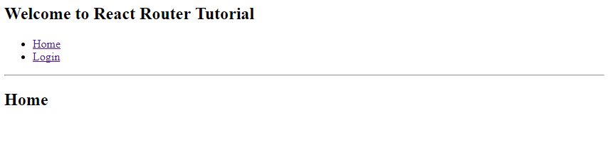

**React JS Flux Components**

**Flux** is a programming concept, where the data is **uni-directional**. This data enters the app and flows through it in one direction until it is rendered on the screen.

## Flux Elements

Following is a simple explanation of the **flux** concept. In the next chapter, we will learn how to implement this into the app.

* **Actions** − Actions are sent to the dispatcher to trigger the data flow.
* **Dispatcher** − This is a central hub of the app. All the data is dispatched and sent to the stores.
* **Store** − Store is the place where the application state and logic are held. Every store is maintaining a particular state and it will update when needed.
* **View** − The **view** will receive data from the store and re-render the app.

The data flow is depicted in the following image.

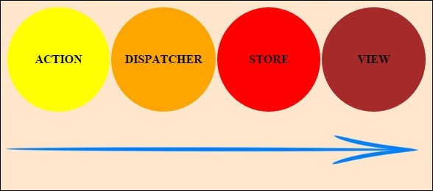

## Flux Pros

* Single directional data flow is easy to understand.
* The app is easier to maintain.
* The app parts are decoupled.

**React JS Using Flux**

In this chapter, we will learn how to implement flux pattern in React applications. We will use **Redux** framework. The goal of this chapter is to present the simplest example of every piece needed for connecting **Redux** and **React**.

## Step 1 - Install Redux

We will install Redux via the **command prompt** window.

C:\Users\username\Desktop\reactApp>npm install --save react-redux

C:\Users\username\Desktop\reactApp>npm install --save redux

## Step 2 - Create Files and Folders

In this step, we will create folders and files for our **actions**, **reducers**, and **components**. After we are done with it, this is how the folder structure will look like.

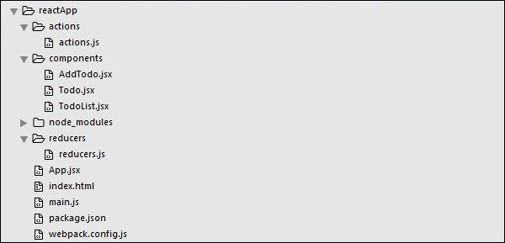

## Step 3 - Actions

Actions are JavaScript objects that use **type** property to inform about the data that should be sent to the store. We are defining **ADD_TODO** action that will be used for adding new item to our list. The **addTodo** function is an action creator that returns our action and sets an **id** for every created item.

### actions/actions.js

export const ADD_TODO = 'ADD_TODO'

let nextTodoId = 0;

export function addTodo(text) {

return {

type: ADD_TODO,

id: nextTodoId++,

text

};

}

## Step 4 - Reducers

While actions only trigger changes in the app, the **reducers** specify those changes. We are using **switch** statement to search for a **ADD_TODO** action. The reducer is a function that takes two parameters (**state** and **action**) to calculate and return an updated state.

The first function will be used to create a new item, while the second one will push that item to the list. Towards the end, we are using **combineReducers** helper function where we can add any new reducers we might use in the future.

### reducers/reducers.js

import { combineReducers } from 'redux'

import { ADD_TODO } from '../actions/actions'

function todo(state, action) {

switch (action.type) {

case ADD_TODO:

return {

id: action.id,

text: action.text,

}

default:

return state

}

}

function todos(state = [], action) {

switch (action.type) {

case ADD_TODO:

return [

...state,

todo(undefined, action)

]

default:

return state

}

}

const todoApp = combineReducers({

todos

})

export default todoApp

## Step 5 - Store

The store is a place that holds the app's state. It is very easy to create a store once you have reducers. We are passing store property to the **provider** element, which wraps our route component.

### main.js

import React from 'react'

import { render } from 'react-dom'

import { createStore } from 'redux'

import { Provider } from 'react-redux'

import App from './App.jsx'

import todoApp from './reducers/reducers'

let store = createStore(todoApp)

let rootElement = document.getElementById('app')

render(

<Provider store = {store}>

<App />

</Provider>,

rootElement

)

## Step 6 - Root Component

The **App** component is the root component of the app. Only the root component should be aware of a redux. The important part to notice is the **connect** function which is used for connecting our root component **App** to the **store**.

This function takes **select** function as an argument. Select function takes the state from the store and returns the props (**visibleTodos**) that we can use in our components.

### App.js

import React, { Component } from 'react'

import { connect } from 'react-redux'

import { addTodo } from './actions/actions'

import AddTodo from './components/AddTodo.js'

import TodoList from './components/TodoList.js'

class App extends Component {

render() {

const { dispatch, visibleTodos } = this.props

return (

<div>

<AddTodo onAddClick = {text ⇒dispatch(addTodo(text))} />

<TodoList todos = {visibleTodos}/>

</div>

)

}

}

function select(state) {

return {

visibleTodos: state.todos

}

}

export default connect(select)(App);

## Step 7 - Other Components

These components shouldn't be aware of redux.

### components/AddTodo.js

import React, { Component, PropTypes } from 'react'

export default class AddTodo extends Component {

render() {

return (

<div>

<input type = 'text' ref = 'input' />

<button onClick = {(e) ⇒ this.handleClick(e)}>

Add

</button>

</div>

)

}

handleClick(e) {

const node = this.refs.input

const text = node.value.trim()

this.props.onAddClick(text)

node.value = ''

}

}

### components/Todo.js

import React, { Component, PropTypes } from 'react'

export default class Todo extends Component {

render() {

return (

<li>

{this.props.text}

</li>

)

}

}

### components/TodoList.js

import React, { Component, PropTypes } from 'react'

import Todo from './Todo.js'

export default class TodoList extends Component {

render() {

return (

<ul>

{this.props.todos.map(todo ⇒

<Todo

key = {todo.id}

{...todo}

/>

)}

</ul>

)

}

}

When we start the app, we will be able to add items to our list.

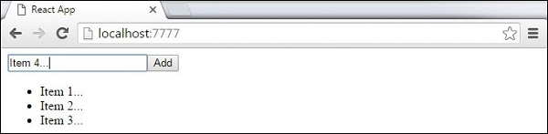

**React JS -Animations**

In this chapter, we will learn how to animate elements using React.

## Step 1 - Install React CSS Transitions Group

This is React add-on used for creating basic CSS transitions and animations. We will install it from the **command prompt** window −

C:\Users\username\Desktop\reactApp>npm install react-addons-css-transition-group

## Step 2 - Add a CSS file

Let's create a new folder **css** and file **style.css** inside. To be able to use it in the app, we need to link it to the **head** element in **index.html**.

<link rel = "stylesheet" type = "text/css" href = "css/style.css">

## Step 3 - Appear Animation

We will create a basic React component. The **ReactCSSTransitionGroup** element will be used as a wrapper of the component we want to animate. It will use **transitionAppear** and **transitionAppearTimeout**, while **transitionEnter** and **transitionLeave** are false.

### App.jsx

import React from 'react';

var ReactCSSTransitionGroup = require('react-addons-css-transition-group');

class App extends React.Component {

render() {

return (

<div>

<ReactCSSTransitionGroup transitionName = "example"

transitionAppear = {true} transitionAppearTimeout = {500}

transitionEnter = {false} transitionLeave = {false}>

<h1>My Element...</h1>

</ReactCSSTransitionGroup>

</div>

);

}

}

export default App;

### main.js

import React from 'react'

import ReactDOM from 'react-dom';

import App from './App.jsx';

ReactDOM.render(<App />, document.getElementById('app'));

The CSS animation is very simple.

### css/style.css

.example-appear {

opacity: 0.01;

}

.example-appear.example-appear-active {

opacity: 1;

transition: opacity 500ms ease-in;

}

Once we start the app, the element will fade in.

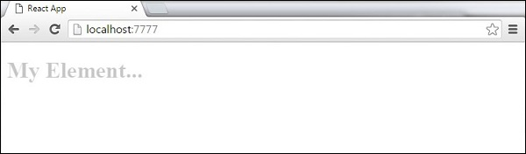

## Step 4 - Enter and Leave Animations

Enter and leave animations can be used when we want to add or remove elements from the list.

### App.jsx

import React from 'react';

var ReactCSSTransitionGroup = require('react-addons-css-transition-group');

class App extends React.Component {

constructor(props) {

super(props);

this.state = {

items: ['Item 1...', 'Item 2...', 'Item 3...', 'Item 4...']

}

this.handleAdd = this.handleAdd.bind(this);

};

handleAdd() {

var newItems = this.state.items.concat([prompt('Create New Item')]);

this.setState({items: newItems});

}

handleRemove(i) {

var newItems = this.state.items.slice();

newItems.splice(i, 1);

this.setState({items: newItems});

}

render() {

var items = this.state.items.map(function(item, i) {

return (

<div key = {item} onClick = {this.handleRemove.bind(this, i)}>

{item}

</div>

);

}.bind(this));

return (

<div>

<button onClick = {this.handleAdd}>Add Item</button>

<ReactCSSTransitionGroup transitionName = "example"

transitionEnterTimeout = {500} transitionLeaveTimeout = {500}>

{items}

</ReactCSSTransitionGroup>

</div>

);

}

}

export default App;

### main.js

import React from 'react'

import ReactDOM from 'react-dom';

import App from './App.jsx';

ReactDOM.render(<App />, document.getElementById('app'));

### css/style.css

.example-enter {

opacity: 0.01;

}

.example-enter.example-enter-active {

opacity: 1;

transition: opacity 500ms ease-in;

}

.example-leave {

opacity: 1;

}

.example-leave.example-leave-active {

opacity: 0.01;

transition: opacity 500ms ease-in;

}

When we start the app and click the **Add Item** button, the prompt will appear.

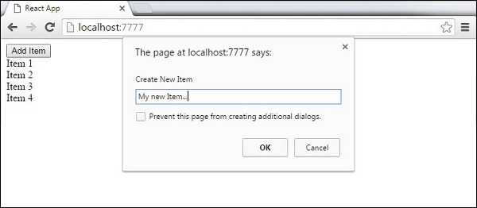

Once we enter the name and press OK, the new element will fade in.

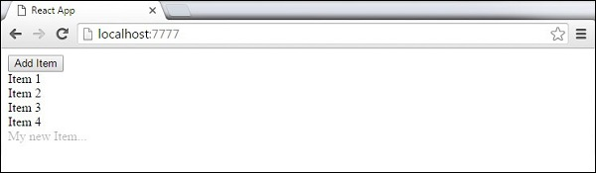

Now we can delete some of the items (**Item 3...**) by clicking it. This item will fade out from the list.

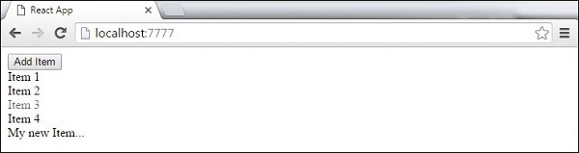

**React JS Higher Order Components**

Higher order components are JavaScript functions used for adding additional functionalities to the existing component. These functions are **pure**, which means they are receiving data and returning values according to that data. If the data changes, higher order functions are re-run with different data input. If we want to update our returning component, we don't have to change the HOC. All we need to do is change the data that our function is using.

**Higher Order Component** (HOC) is wrapping around "normal" component and provide additional data input. It is actually a function that takes one component and returns another component that wraps the original one.

Let us take a look at a simple example to easily understand how this concept works. The **MyHOC** is a higher order function that is used only to pass data to **MyComponent**. This function takes **MyComponent**, enhances it with **newData** and returns the enhanced component that will be rendered on the screen.

import React from 'react';

var newData = {

data: 'Data from HOC...',

}

var MyHOC = ComposedComponent ⇒ class extends React.Component {

componentDidMount() {

this.setState({

data: newData.data

});

}

render() {

return <ComposedComponent {...this.props} {...this.state} />;

}

};

class MyComponent extends React.Component {

render() {

return (

<div>

<h1>{this.props.data}</h1>

</div>

)

}

}

export default MyHOC(MyComponent);

If we run the app, we will see that data is passed to **MyComponent**.

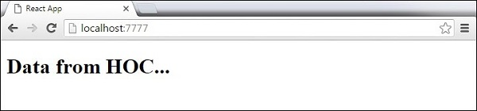

**Note** − Higher order components can be used for different functionalities. These pure functions are the essence of functional programming. Once you are used to it, you will notice how your app is becoming easier to maintain or to upgrade.

**Single Page Application Project Using Bootstrap**

**To add React Bootstrap through npm**

Create a basic app folder and add two more node modules-

The syntax is like as –

* “npm install –save react-bootstarp”
* “npm install – save react-router-dom”

Now copy the link and paste it into the index.html file –

The link is – or visit the website ”reactbootstrap”

<!-- Latest compiled and minified CSS -->

<link rel="stylesheet" href="https://maxcdn.bootstrapcdn.com/bootstrap/3.3.7/css/bootstrap.min.css" integrity="sha384-BVYiiSIFeK1dGmJRAkycuHAHRg32OmUcww7on3RYdg4Va+PmSTsz/K68vbdEjh4u" crossorigin="anonymous">

<!-- Optional theme -->

<link rel="stylesheet" href="https://maxcdn.bootstrapcdn.com/bootstrap/3.3.7/css/bootstrap-theme.min.css" integrity="sha384-rHyoN1iRsVXV4nD0JutlnGaslCJuC7uwjduW9SVrLvRYooPp2bWYgmgJQIXwl/Sp" crossorigin="anonymous">

* Rename the file “App.js” as “App.jsx” to make it auto complete <html tag> when you will write the code.
* Create assest folder inside the public folder to keep your image and any file
* Public>assets.
* Now create some components like-

Src>components>

-home.jsx

-home.css

-about.jsx

-about.css

-news.jsx

-news.css

-customnavbar.jsx

-customnavbar.css

Work on the home.jsx file

import React, { Component } from 'react';

// to import the link to navigate from ract-router components

import { Link } from 'react-router-dom';

import { Jumbotron, Image, Button, Row, Col, Grid} from 'react-bootstrap';

// import the home css file

import './home.css';

importCustomNavbar from './customnavbar';

importBodyPanel from './bodypanel';

class Home extends Component {

render() {

return (

<Grid>

<div>

<Row className ="page_header">

<Col md = {3}>

<Link to = "/">

<Image src= "/assets/site_logo.png" className ="site_image" />

</Link>

</Col>

<Col md = {9} className ="site_title">

<h2>Single Page Application</h2>

</Col>

</Row>

<Row>

<CustomNavbar />

</Row>

<Row>

<BodyPanel />

</Row>

</div>

{/* <Link to = "/about">

<Button bsStyle = " btnbtn-primary">About</Button>

</Link>

<Link to = "/news">

<Button bsStyle = "btnbtn-danger">News</Button>

</Link> */}

</Grid>

);

}

}

export default Home;

Work on App.jsx file

import React, { Component } from 'react';

// import the browser router dependencies from react-router-dom

import { BrowserRouter as Router, Route} from 'react-router-dom';

import './App.css';

// import all the components which you have created

import Home from './components/home';

import About from './components/about';

import News from './components/news';

class App extends Component {

render() {

return (

<Router>

<div>

<Route exact path = "/" component = {Home} />

<Route path = "/about" component = {About} />

<Route path = "/news" component = {News} />

</div>

</Router>

);

}

}

export default App;

Work on CustomNavbar.jsx

import React, { Component } from 'react';

import { Navbar, Nav, Row, NavItem, MenuItem, NavDropdown} from 'react-bootstrap';

import './customnavbar.css';

classCustomNavbar extends Component {

render() {

return (

<div className = "demo_nav">

<Navbar inverse>

<Navbar.Header>

<Navbar.Brand>

<a href="/">Home</a>

</Navbar.Brand>

</Navbar.Header>

<Nav>

<NavItemeventKey={1} href="/News">

News

</NavItem>

<NavItemeventKey={2} href="/About">

About

</NavItem>

<NavDropdowneventKey={3} title="Service" id="basic-nav-dropdown">

<MenuItemeventKey={3.1}>Web Application</MenuItem>

<MenuItem divider />

<MenuItemeventKey={3.2}>Digital Marketing</MenuItem>

<MenuItem divider />

<MenuItemeventKey={3.3}>Google Map API</MenuItem>

<MenuItem divider />

<MenuItemeventKey={3.4}>Business Solution</MenuItem>

</NavDropdown>

</Nav>

</Navbar>

</div>

);

}

}

export default CustomNavbar;

Work on bodypanel.jsx –

import React, { Component } from 'react';

import {Grid, Row, Col, Carousel} from 'react-bootstrap'

import './bodypanel.css';

classBodyPanel extends Component {

render() {

return (

<div>

<Grid>

<Row className = "slider_section">

<Carousel>

<Carousel.Item>

<img alt = "Slider Image" src="/assets/slider_1.jpg" />

<Carousel.Caption>

<h3>First slide label</h3>

<p>Nulla vitae elitlibero, a pharetraauguemollisinterdum.</p>

</Carousel.Caption>

</Carousel.Item>

<Carousel.Item>

<img alt = "Slider Image" src="/assets/slider_2.jpg" />

<Carousel.Caption>

<h3>Second slide label</h3>

<p>Loremipsum dolor sit amet, consecteturadipiscingelit.</p>

</Carousel.Caption>

</Carousel.Item>

<Carousel.Item>

<img alt = "Slider Image" src="/assets/slider_1.jpg" />

<Carousel.Caption>

<h3>Third slide label</h3>

<p>Praesentcommodocursus magna, velscelerisquenislconsectetur.</p>

</Carousel.Caption>

</Carousel.Item>

</Carousel>

</Row>

<Row className = "body_text">

<h1>This is the Paragraph text you can include more text here...</h1>

</Row>

</Grid>

</div>

);

}

}

export default BodyPanel;

Application Design –

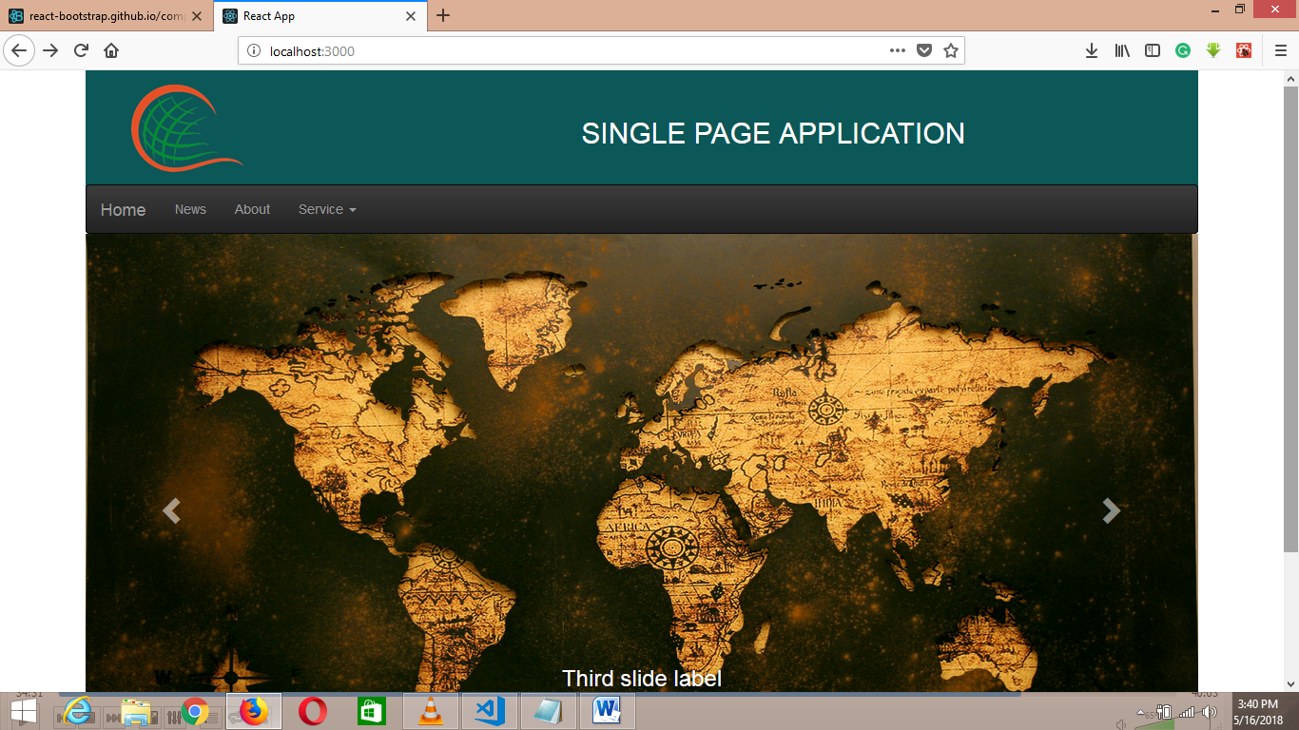

**Important Notes :**

* Make css code easy you have to install the react-bootstrap
* To navigate the page link you have to install the
* React router-dom which I have discuss before.
* Study the code properly you can easily develop the single page application in react.

**Weather Application Using API**

* Create a Project folder using npm command like-
* “create-react-app weather-app”
* Now remove the content of the file-

-app.js

-app.css

-delete the logo

Create component folder inside the src.

* Src>components>

-title.js

Work on title.jsx-

import React, { Component } from 'react';

class Title extends Component {

render() {

return (

<div>

<h1>Weather Finder App</h1>

<p>Find out temprature , conditions and more...</p>

</div>

);

}

}

export default Title;

Work on form.jsx components –

import React from 'react';

class Form extends React.Component{

render(){

return(

<div>

this is my form component

</div>

); // end of return

}// end of render

}// end of class

// export it to use in another components

export default Form;

Work on weather.jsx components-

import React from 'react';

class Weather extends React.Component{

render(){

return(

<div>

this is my weather components

</div>

); // end of return function

}//end of render method

}// end of class

// export this component to use in other componets

export default Weather;

* Now create an account on “openweathermap.org” to cal an API from URL.

The screen after create Account –

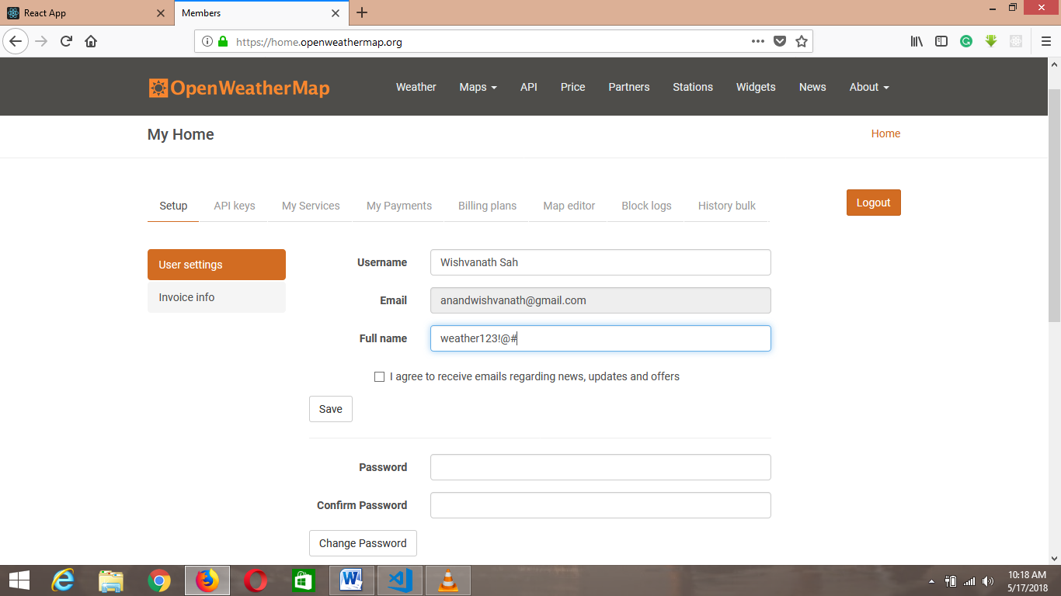

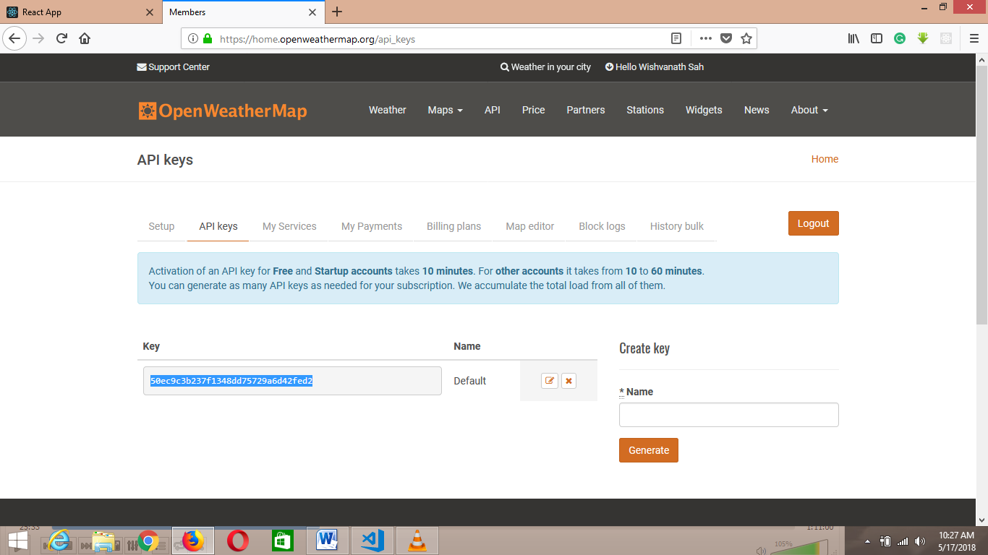

Copy the API key and make it store it in const variable in App.jsx file like-

Work on App.jsx file –

importReact, { Component } from'react';

import'./App.css';

importTitlefrom'./components/Title'

importFormfrom'./components/Form';

importWeatherfrom'./components/Weather';

constAPI_KEY = "50ec9c3b237f1348dd75729a6d42fed2";

classAppextendsComponent {

render() {

return (

<div>

<Title/>

<Form/>

<Weather/>

</div>

);

}

}

exportdefaultApp;

Now search one API Url the link is –

<http://samples.openweathermap.org/data/2.5/weather?q=London,uk&appid=b6907d289e10d714a6e88b30761fae22>

Now create your own method in App.jsx file –

There is two way to create the method

Using the constructor-

constructor(props){

super(props);

// bind the method

this.getWeather = this.getWeather.bind(this);

}

getWeather(){

} // end of getWeather method

And another method is using self inner function like –

Self Innerfunction allow use to this keyword inside the reder function.

The syntax is like as –

// self Inner function

getWeather = () =>{

}// end of getWeather function

Now to call the Api_call inside the function –

// self Inner function

getWeather = async () =>{

// fetch the api call

constapi_call = awaitfetch(`http://samples.openweathermap.org/data/2.5/weather?q=London,uk&appid=b6907d289e10d714a6e88b30761fae22`);

}// end of getWeather function

Now replace the “appid” with your Api key const variable which you have created before-

// self Inner function

getWeather = async () =>{

// fetch the api call

constapi_call = awaitfetch(`http://samples.openweathermap.org/data/2.5/weather?q=London,uk&appid= ${API_KEY}`);

}// end of getWeather function

Now after fetching the data from “api_call” we need to convert this data into the json format.

And check it in console .rember that we have not call this function in an event so –

getWeather = async () =>{

// fetch the api call

constapi_call = awaitfetch(`http://samples.openweathermap.org/data/2.5/weather?q=London,uk&appid= ${API_KEY}`);

// convert the api_call data into the json format

constdata = awaitapi_call.json();

// check the json data into the console

console.log("data");

}// end of getWeather function

Now call the getWeather() in any event like –

Work on the <Form /> component to take the input( means the design part)

To bring the intelligence window in visual code editor press “ctrl + spacebar”

importReactfrom'react';

classFormextendsReact.Component{

render(){

return(

<div>

<formonSubmit = {this.props.getWeather}>

<inputtype = "text"name = "city"placeholder = "City Name"/>

<inputtype = "text"name = "country"placeholder ="Your Country"/>

<buttontype = "submit">Get Weather</button>

</form>

</div>

); // end of return

}// end of render

}// end of class

// export it to use in another components

exportdefaultForm;

now run in browser

Note : you can get some error so you need to run this application in your internet explorer.

Work on App.jx file –

importReact, { Component } from'react';

import'./App.css';

importTitlefrom'./components/Title'

importFormfrom'./components/Form';

importWeatherfrom'./components/Weather';

constAPI_KEY = "1ac2a9ad789f1cdd93957ef6c6c4db0b";

classAppextendsComponent {

// self Inner function

getWeather = async (e) =>{

// to prevent the full page refresh

e.preventDefault();

constcity = e.target.elements.city.value;

constcountry = e.target.elements.country.value;

// chek the value in console

console.log(city);

console.log(country);

// fetch the api call

constapi_call = awaitfetch(`http://samples.openweathermap.org/data/2.5/weather?q=${city},${country}&appid= ${API_KEY}`);

// constapi_call = await fetch('http://samples.openweathermap.org/data/2.5/weather?q=London,uk&appid=b6907d289e10d714a6e88b30761fae22');

// convert the api_call data into the json format

constdata = awaitapi_call.json();

// check the json data into the console

console.log(data);

}// end of getWeather function

render() {

console.log(this.getWeather);

return (

<div>

<Title/>

{/* to call the getWeather function we need to set props so props is nothing like properties in html which gives to use in another component */}

<FormgetWeather = {this.getWeather}/>

{/* now this getWeather method is able to use in form component using the props concept */}

<Weather/>

</div>

);

}

}

exportdefaultApp;

here we are cheking the data in console now need to display this data into the UI-

so to show the data in UI we need to define the state

there is two way to define the state-

using constructor method –

// define the state

constructor(props){

super(props);

this.state = {

}

}

Another Method –

// define the state

state = {

temperature:undefined,

city:undefined,

country:undefined,

humidity:undefined,

description:undefined,

error:undefined

}

Now set the value of this state-

importReact, { Component } from'react';

import'./App.css';

importTitlefrom'./components/Title'

importFormfrom'./components/Form';

importWeatherfrom'./components/Weather';

constAPI_KEY = "1ac2a9ad789f1cdd93957ef6c6c4db0b";

classAppextendsComponent {

// define the state

state = {

temperature:undefined,

city:undefined,

country:undefined,

humidity:undefined,

description:undefined,

error:undefined

}

// self Inner function

getWeather = async (e) =>{

// to prevent the full page refresh

e.preventDefault();

constcity = e.target.elements.city.value;

constcountry = e.target.elements.country.value;

// chek the value in console

// console.log(city);

// console.log(country);

// fetch the api call

constapi_call = awaitfetch(`http://samples.openweathermap.org/data/2.5/weather?q=${city},${country}&appid= ${API_KEY}`);

// constapi_call = await fetch('http://samples.openweathermap.org/data/2.5/weather?q=London,uk&appid=b6907d289e10d714a6e88b30761fae22');

// convert the api_call data into the json format

constdata = awaitapi_call.json();

// check the json data into the console

console.log(data);

// now set the state value

this.setState({

temperature:data.main.temp,

city:data.name,

country:data.sys.country,

humidity:data.main.humidity,

description:data.weather[0].description,

error:""

});

}// end of getWeather function

render() {

console.log(this.getWeather);

return (

<div>

<Title/>

{/* to call the getWeather function we need to set props so props is nothing like properties in html which gives to use in another component */}

<FormgetWeather = {this.getWeather}/>

{/* now this getWeather method is able to use in form component using the props concept */}

<Weather/>

</div>

);

}

}

exportdefaultApp;

now pass the value of this state in weather component to show the data using the props concept the code will look like this-

importReact, { Component } from'react';

import'./App.css';

importTitlefrom'./components/Title'

importFormfrom'./components/Form';

importWeatherfrom'./components/Weather';

constAPI_KEY = "1ac2a9ad789f1cdd93957ef6c6c4db0b";

classAppextendsComponent {

// define the state

state = {

temperature:undefined,

city:undefined,

country:undefined,

humidity:undefined,

description:undefined,

error:undefined

}

// self Inner function

getWeather = async (e) =>{

// to prevent the full page refresh

e.preventDefault();

constcity = e.target.elements.city.value;

constcountry = e.target.elements.country.value;

// chek the value in console

// console.log(city);

// console.log(country);

// fetch the api call

constapi_call = awaitfetch(`http://samples.openweathermap.org/data/2.5/weather?q=${city},${country}&appid= ${API_KEY}`);

// constapi_call = await fetch('http://samples.openweathermap.org/data/2.5/weather?q=London,uk&appid=b6907d289e10d714a6e88b30761fae22');

// convert the api_call data into the json format

constdata = awaitapi_call.json();

// check the json data into the console

console.log(data);

// now set the state value

this.setState({

temperature:data.main.temp,

city:data.name,

country:data.sys.country,

humidity:data.main.humidity,

description:data.weather[0].description,

error:""

});

}// end of getWeather function

render() {

console.log(this.getWeather);

return (

<div>

<Title/>

{/* to call the getWeather function we need to set props so props is nothing like properties in html which gives to use in another component */}

<FormgetWeather = {this.getWeather}/>

{/* now this getWeather method is able to use in form component using the props concept */}

<Weather

temperature= {this.state.temperature}

city = {this.state.city}

country = {this.state.country}

humidity = {this.state.humidity}

description = {this.state.description}

error = {this.state.error}

/>

</div>

);

}

}

exportdefaultApp;

Now work on the <Weather />

Now we have to access the app.js props into the weather components the code will look like this –

importReactfrom'react';

classWeatherextendsReact.Component{

render(){

return(

<div>

{/* now call the state value using the concept of the props */}

Temperature:{this.props.temperature}

City Name:{this.props.city}

Country Name: {this.props.country}

Humidity: {this.props.humidity}

Desceription:{this.props.description}

</div>

); // end of return function

}//end of render method

}// end of class

// export this component to use in other componets

exportdefaultWeather;

Now the problem is we are getting the empty string value on the form

So omit the string value until the press getweather button.

We can not use the if else operator in react instead of that we can use the conditional operater the syntax is like ---

(condition) ? statement1:statement2;

Or we can use the and operater(&&)

importReactfrom'react';

classWeatherextendsReact.Component{

render(){

return(

<div>

{/* now call the state value using the concept of the props */}

{/* <p>Temperature:{this.props.temperature} </p>

<p>City Name:{this.props.city}</p>

<p>Country Name: {this.props.country}</p>

<p> Humidity: {this.props.humidity}</p>

<p>Desceription:{this.props.description}</p> */}

{/* to omit the empty sting on the screen use the concept of and operator */}

{this.props.temperature&&<p>Temperature:{this.props.temperature}</p>}

{this.props.country&&<p>Country Name: {this.props.country}</p>}

{this.props.city&&<p>City Name:{this.props.city}</p>}

{this.props.humidity&&<p> Humidity: {this.props.humidity}</p>}

{this.props.description&&<p>Desceription:{this.props.description}</p>}

</div>

); // end of return function

}//end of render method

}// end of class

// export this component to use in other componets

exportdefaultWeather;

Now your application is ready to go -

The screen short is –

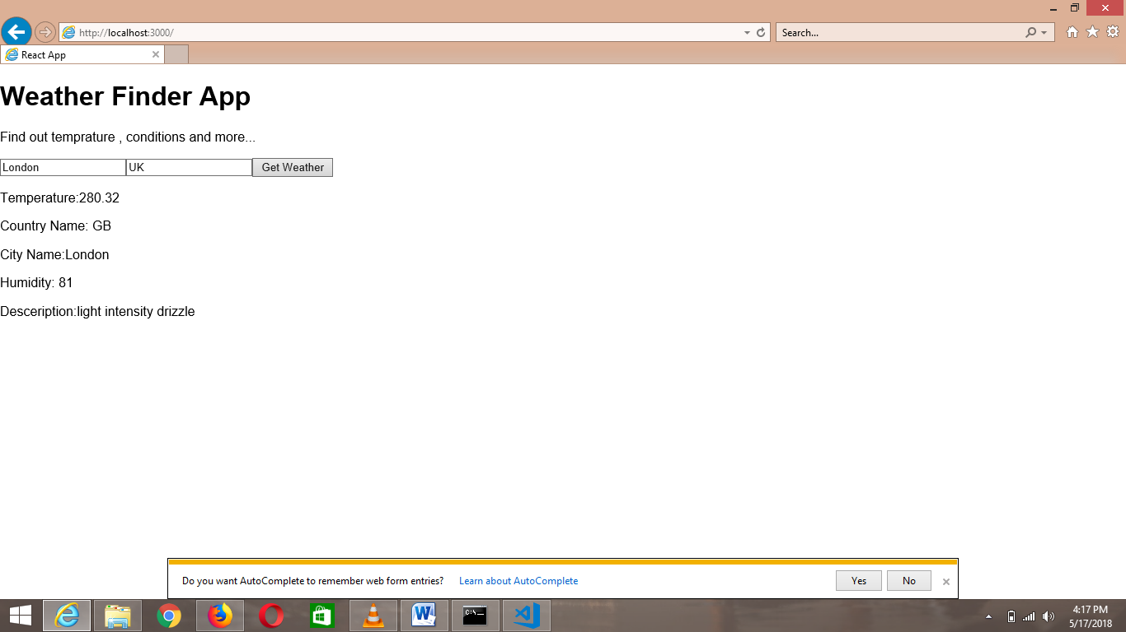

Console screen-

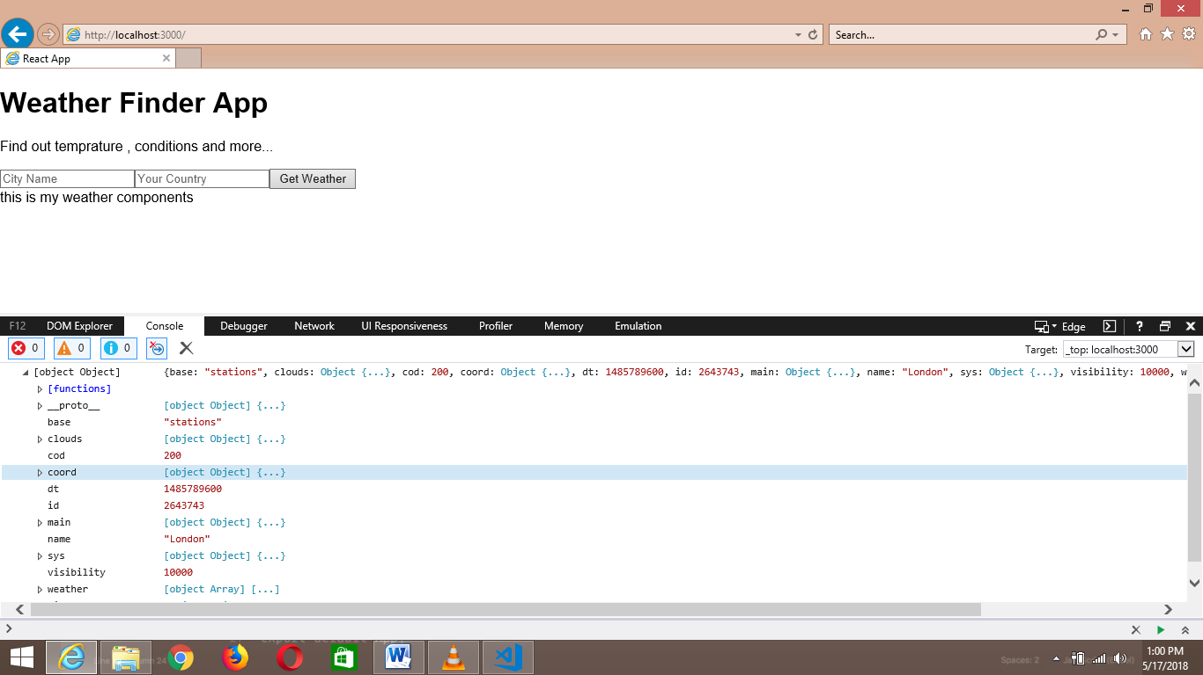

So the next thing is we need these data in UI not in console

CREATE A TODO APPLICATION IN REACT-

First create a app folder of “todo” app and navigate it into your code editor start the server and edit the code. Instruction is given below.

The folder hierarchy –

TODOAPP-

* node_modules
* public
* src

- components

-header.js

-todoinput.js

-todoitems.js

-todoinput.css

-todoitems.css

-App.css

-App.js

-index.css

-index.js

-registerServiceWorker.js

- .gitignore

- package-lock.json

- package.json

App.js file-

import React from ‘react’;

import ‘./App.css’;

import Header from ‘./components/header’;

importTodoInput from ‘./components/todoinput’;

importTodoItems from ‘./components/todoitems’;

// create an App class which will extends the react components

Class App extends React.Component{

// define the constructor

Constructor(props){

Super(props);

This.state = {

Todos:[

{id:0, text:”wishvanath”},

{id:1, text:”anand”}

],

nextId :2

}// end of state

// bind the function

This.addTodo = this.addTodo.bind(this);

This.removeTodo = this.removeTodo(this);

}// end of constructor

// define the function

addTodo(todoText){

// check in console is method working or not

Console.log(“Text is Adding”);

}

removeTodo(id){

// check in console

Console.log(item is removing”);

}

Render(){

Return(

<div className = “App”>

<div className =”todoWrapper”>

<Header/>// include header component

// include todoInput components

<TodoInputtodoText = “” addTodo = {this.addTodo}/>

// show the data of define state under ul tag

<ul>

// show the data using map function

{

This.state.todos.map( (todo) => {<TodoItemstodo = {todo} key = {todo.id} id = {todo.id} removeTodo = {this.removeTodo}/>})

} </ul>

</div>

</div>

);

}// end of render method

Export default App;

Header.js Components-

Import React from ‘react’;

Import ‘./App.cs’;

Class Header extends React.Component{

Render(){

Return(

<div>

<h1>React To do Application </h1>

<hr>

</div>

); // end of return  
}// end of render

} // end of component

Export default Header;

Todoinput.js Components-

Import React from ‘react’;

Import ‘./components/todoinput.css’;

Class TodoInput extends React.Componet{

// define the constructor

Constructor(props){

Super(props);

// bind the function which you defined in the input box and on button

This.handleChange = this.handleChange.bind(this);

This.addTodo = this.addTodo.bind(this);

This.state = {

Value : “” ,// empty value

}// end of state

}// end of constructor

// define the function

handleChange(e){

// set the target value

This.setState({value:e.target.value });

}// end of handle change

addTodo(todo){

// ensure that input box is not empty

If(todo.length> 0){

This.props.addTodo(todo);

This.setState = ({value:””});

}

}//end of addTodo

Render(){

Return(

<div>

<input type = “text” value = {this.state.value} onChange = {this.handleChange} />

<button type = “submit” onClick = “{() = >this.addTodo(this.state.value)} >Submit </button>

</div>

); // end of return

}// end of render method

}// end of component

Export default TodoInput;

Todoitems.js Components-

Import React from ‘react’;

Import ‘./components/todoitems.css;

Class TodoItems extends React.Component{

// define the constructor

Constructor(props){

Super(props);

// no need to bind the function of removeTodo

} // end of constructor

// define the reomoveTodo()

removeTodo(id){

this.props.removeTodo(id);

} // end of remove todo

Render(){

Return(

<div className =”todoWrapper”>

<button className = “ remove_btn” onClick = {(e) => this.removeTodo(this.props.id)}>Remove</button>{this.props.todo.text}

</div>

); // end of return

} // end of render

}// end of component

Export default TodoItems;

-------Wishvanath Anand---------------------------------------------------------**THE END**